Open a Repair Order in ROM – NO Unit: This topic covers how to open a repair order when you do not have access to the unit’s information.

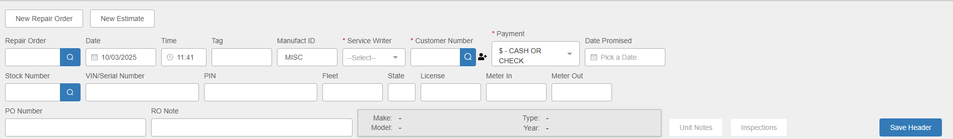

New Repair Order: ROM should be set to begin a new repair order as soon as you open the program, but you can always click this button at any point to start a new order. NOTE: If you want to create an estimate rather than an RO, click New Estimate instead and follow the same steps.

Header Fields:

Repair Order: This field will hold the RO number. You only need to fill in a new RO number if you do not have your system set to auto-assign RO numbers, or if you have a paper RO that already has an assigned number on it. If you have the auto-assign function turned on in Service Options & Defaults (SOD), the field will automatically fill in with a number once you finish creating the header. NOTE: You can also use the field to look up and open an existing repair order.

Date: This field will default to the current date, but you may change it by entering a new date or selecting one from a calendar.

Time: This field will default to the time when you started creating the new order, but you may change it by entering a new time in the field. The clock is set to military time (1-24 instead of 1-12), and the field will reject any entry that does not represent an actual time of day.

Tag: This field is currently an informational field only – not required.

Manufact ID: This field holds the manufacturer ID for the unit being repaired. It defaults to “MISC.”

Service Writer: Type in the service writer’s ID or select it using the dropdown.

Customer Number: Enter the customer’s number here or look it up using the Search function. If the customer is not found, you can use the New Customer icon next to the field to create a record for the customer. NOTE: If you see a pop-up box of open repair orders for this customer such as the one below, click the Start New RO button to bypass it.

Payment: The Method of Payment (MOP) defaults based on the customer’s Master record in Enter Customer Information (ECI). This is only a suggested payment option. During Settlement, you will still have the chance to change it, though you need to have one selected in the Header to create the RO.

Skip the following fields:

- Stock Number
- VIN/Serial Number
- PIN
- Tag
- Fleet
- ST
- License

RO Note: You may use the RO note field to document some of the details of the item being repaired. This will print on the Tech Copy and Invoice.

Save Header: Press this button to save the header information. RO # has been assigned (you will see it grayed out in the top of the header), but the section holding the unit information will have a message indicating one is missing:

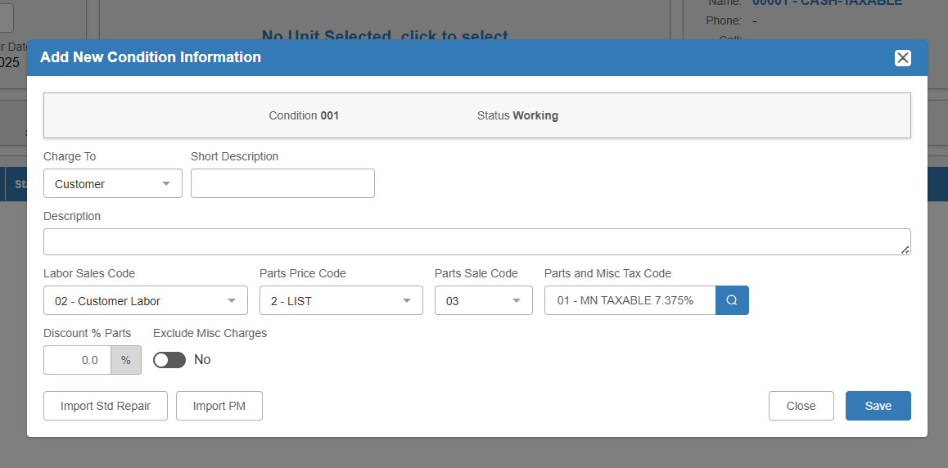

Add New Condition: Proceed to add the first condition as you would with a normal RO.

Charge To: Select the desired condition charge type (Customer, Internal, Warranty, Other). NOTE: We do not recommend creating an Internal RO without a unit, or at least not

Short Description: Fill in a brief description of the repair needed.

Description: You may fill in more details of the repair needed if desired. This is a good place to put in details of the item being repaired.

Codes: These codes will default from the Customer Master. Change/select only if needed using drop-down menus or arrows.

- Labor Sales Code
- Parts Price Code
- Parts Sales Code
- Parts Tax Code

Discount % Parts: Fill in this field if applicable.

Save: Click this butt to save the description.

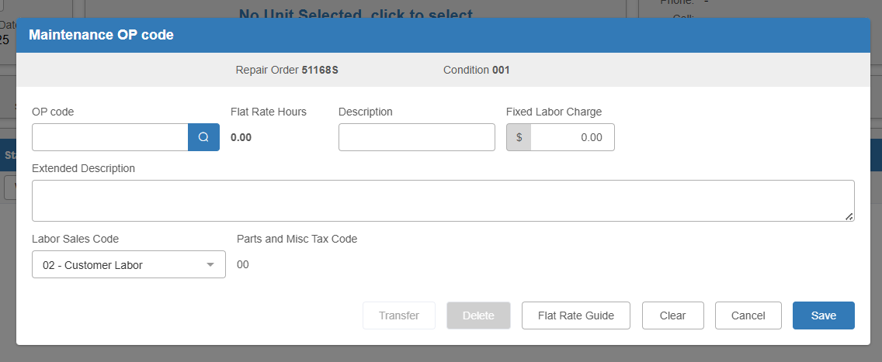

OP Code: Add the condition’s Op Code(s) as you normally would.

Processing RO without a Stock Number: The RO from this point can be treated as normal working through it. However, you will need to add a stock number to the RO at some point prior to invoicing the RO, especially if this is an Internal RO.

